PORTABLE SSD MARKET
RESEARCH REPORT
10-Product Competitive Analysis
Amazon FBA & eBay Marketplace Intelligence
Prepared: June 2026

This report covers 10 portable SSD products across premium and budget segments, analyzing brand positioning, competitive landscape, private-label opportunity, and seller entry feasibility for Amazon FBA and eBay marketplace strategies.

Market Overview

Category Dynamics
Category: Portable External SSD (1TB Primary Focus)
Primary Marketplace: Amazon.com (FBA) + eBay
Price Range Analyzed: $15 — $139
Market Maturity: High — established with continued growth
Entry Difficulty: Medium (budget segment) to Very High (premium segment)

Buyer Demand Drivers
- Content creators (YouTubers, photographers, videographers) need fast, portable backup solutions
- Remote and hybrid workers require reliable external storage for document and project portability
- Gamers expanding PlayStation, Xbox, and PC storage capacity
- Students and professionals backing up sensitive data
- Travelers wanting lightweight storage without cloud dependency

Competitive Landscape Summary
Factor | Premium Brands (1-3) | Budget Brands (4-6) | Unconfirmed (7-10)
Market Demand | Very High | High | Unknown
Competition Level | Extremely High | High | Medium
Brand Importance | Critical | Medium | Low
Profit Margin (Est.) | Low for Resellers | Moderate-High | Unconfirmed
Return Risk | Moderate | High | High
Private Label Potential | Very Low | Medium-High | Medium
Entry Barrier | Very High | Medium | Low
Recommended Action | Benchmark Only | Investigate & Source | Confirm Listings First

Individual Product Analysis
The following section provides a detailed breakdown of each of the 10 products in this research scope. Each product is evaluated on brand trust, features, competitive strengths and weaknesses, and market opportunity for new sellers.

Product 2 of 10

SanDisk Extreme Portable SSD - 1TB (Black)

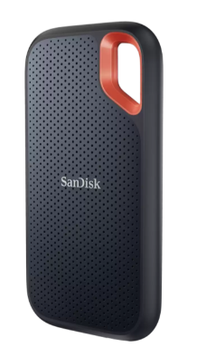
Product Page: https://www.westerndigital.com/products/portable-drives/sandisk-extreme-usb-3-2-ssd
Product Overview

Brand | SanDisk (Western Digital)
Market Segment | Premium Consumer / Creator
Trust Rating | ★★★★★
Estimated Price | $89–$109 (typical retail)
Advertised Speed | Up to 1,050 MB/s read / 1,000 MB/s write

Key Features
- IP65 water and dust resistance
- Drop-resistant up to 2 meters
- NVMe performance
- 256-bit AES hardware encryption
- USB-C interface (USB 3.2 Gen 2)
- Compatible with PC, Mac, Android, iPad Pro

Strengths
- Industry-leading brand recognition among content creators
- Strong retail and online distribution
- Consistent top-10 Amazon BSR in portable SSD category
- Supported by WD's global warranty infrastructure

Weaknesses
- Very high competition — hard to displace
- Thin margins for resellers due to MAP pricing
- Heavy saturation on Amazon (many third-party sellers)

Market Opportunity Assessment
Low for new private-label sellers. This product defines the premium benchmark — study its listing, A+ content, and reviews for competitive intelligence.

Product 2 of 10

Samsung T7 Portable SSD 1TB
https://www.samsung.com/us/business/support/owners/product/t7-series-1tb/
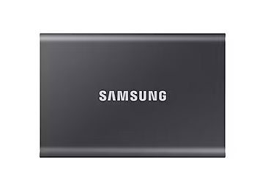
Product Overview

Brand | Samsung Electronics
Market Segment | Premium Consumer
Trust Rating | ★★★★★
Estimated Price | $79–$99 (typical retail)
Advertised Speed | Up to 1,050 MB/s read / 1,000 MB/s write

Key Features
- Aluminum metal build
- 256-bit AES encryption
- USB 3.2 Gen 2 (10 Gbps)
- Dynamic Thermal Guard
- Available in 3 colors
- Compatible with PC, Mac, Android

Strengths
- Samsung brand = premium consumer trust globally
- Sleek minimal design appeals to lifestyle buyers
- Broad compatibility and wide distribution
- Strong Amazon review base (20,000+ reviews)

Weaknesses
- Near-impossible brand advantage to replicate
- Price competition from newer OEM brands
- Limited differentiation opportunity for resellers

Market Opportunity Assessment
Low. Use this product as a pricing anchor. Understand its review velocity and average star rating to compare against budget competitors.

Product 3 of 10

Samsung T9 Portable SSD 1TB
https://www.samsung.com/ca/support/model/MU-PG4T0B/AM/
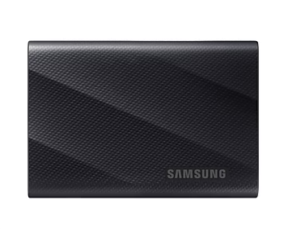

Product Overview

Brand | Samsung Electronics
Market Segment | Premium Pro / Power Users
Trust Rating | ★★★★★
Estimated Price | $109–$139 (typical retail)
Advertised Speed | Up to 2,000 MB/s read / 1,950 MB/s write

Key Features
- USB 3.2 Gen 2x2 (20 Gbps)
- Shock-resistant rubber exterior
- Dynamic Thermal Guard
- 256-bit AES encryption
- Works with USB4 and Thunderbolt 3/4 devices

Strengths
- Fastest portable SSD in Samsung's lineup
- Targets professional videographers and developers
- Premium pricing supports higher perceived value
- Future-proof for next-gen USB standards

Weaknesses
- Requires USB 3.2 Gen 2x2 host for max speeds
- Higher price point limits mass-market appeal
- Very competitive in the pro segment

Market Opportunity Assessment
Low for direct competition, but understand this segment — it shows where the market is heading. Speed benchmarks here set future buyer expectations.

Product 4 of 10

SSK Portable SSD
https://sskssd.com/
Specific product;
https://www.amazon.com/SSK-Portable-External-Transmission-Smartphone/dp/B0BGL4SHY8?th=1&linkCode=sl2&tag=sskssd.com-20&linkId=56a58ce4d5a6c50f5f000d815cb135b6&language=en_US&ref_=as_li_ss_tl
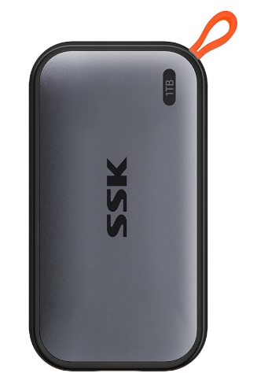
Product Overview

Brand | SSK
Market Segment | Budget / Value-Oriented
Trust Rating | ★★★
Estimated Price | $25–$45 (typical range)
Advertised Speed | Up to 550 MB/s read (advertised)

Key Features
- Compact aluminum casing
- USB 3.1 interface
- Plug-and-play (no driver required)
- Compatible with Windows, Mac, Linux, Android
- Shock-resistant design claim

Strengths
- Aggressive pricing attracts budget buyers
- Growing review count suggests traction
- OEM-style construction suggests sourceable supply chain
- Can rank well with competitive PPC campaigns

Weaknesses
- Brand recognition is minimal globally
- Advertised speeds may not be achievable in real-world tests
- High return risk if expectations aren't managed
- Customer trust gap vs. name brands

Market Opportunity Assessment
Medium. SSK-style products are exactly where new Amazon sellers operate. If the factory source can be identified and quality controlled, similar products can be launched with better branding and listing optimization.

Product 5 of 10

Ediloca Portable SSD
Product link
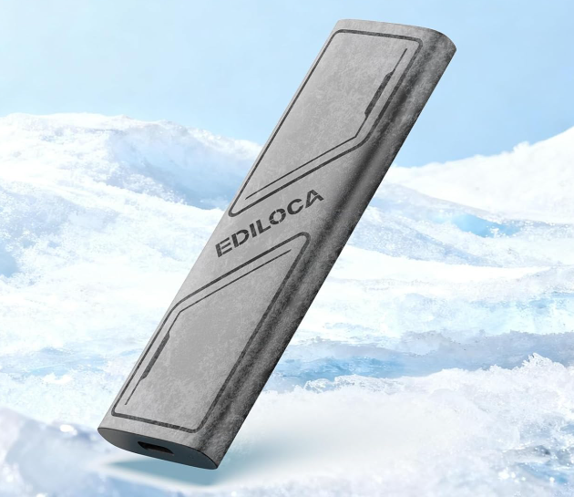

Product Overview

Brand | Ediloca
Market Segment | Budget / Emerging Brand
Trust Rating | ★★★
Estimated Price | $20–$40 (typical range)
Advertised Speed | Up to 550 MB/s read (advertised)

Key Features
- Compact portable form factor
- USB 3.1 Gen 2 interface
- Aluminum shell
- No external power required
- Wide device compatibility

Strengths
- Very aggressive pricing draws click-throughs
- Low barrier to entry for buyers
- Review growth suggests algorithm traction
- Small brand = potential to undercut on listings

Weaknesses
- No recognizable brand story
- Limited product line depth
- Quality consistency unknown without sampling
- High dependence on price vs. value narrative

Market Opportunity Assessment
Medium. Ediloca is a benchmark for what a new private-label brand looks like in early stages. Monitor its review growth rate — if it's gaining 100+ reviews per month, the market is receptive to new entrants at this price point.

Product 6 of 10

OSCOO Portable SSD
Product Page
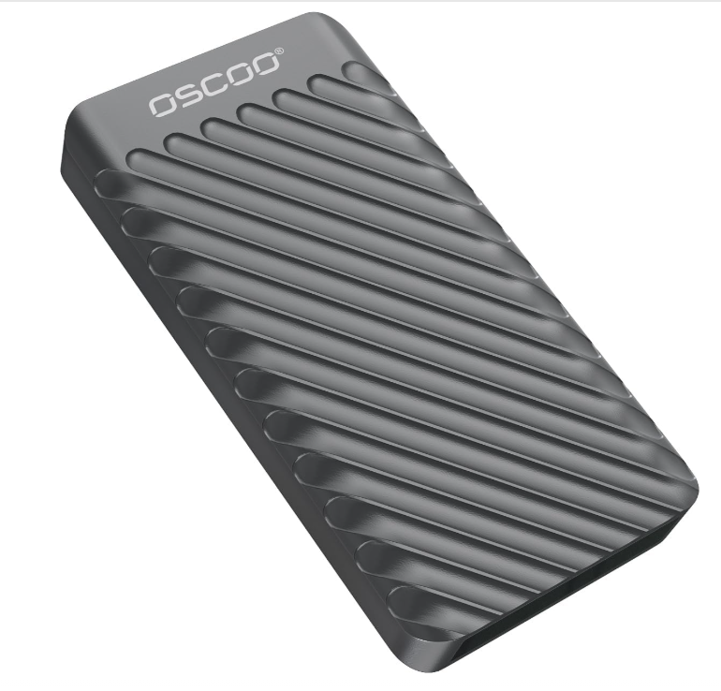
Product Overview

Brand | OSCOO
Market Segment | Budget / Value-Focused
Trust Rating | ★★
Estimated Price | $18–$35 (typical range)
Advertised Speed | Up to 520 MB/s read (advertised)

Key Features
- Slim, lightweight casing
- USB 3.1 interface
- No installation required
- Compatible with multiple operating systems
- 1–2 year manufacturer warranty claim

Strengths
- Lowest price tier attracts high click volume
- Minimal listing maturity — room to outcompete
- Product design suggests white-label availability
- Accessible for FBA new seller entry

Weaknesses
- Very low brand trust signals
- Sparse or weak review base
- Higher-than-average return and dispute rates expected
- Customer service challenges for no-name brands

Market Opportunity Assessment
Medium-High from an entry standpoint, but with significant risk. The low review count and weak brand are double-edged: easy to outrank with a better listing, but also a signal that the market may punish lower-quality products quickly.

Product 7 of 10

KOOTION Portable SSD
Product Page

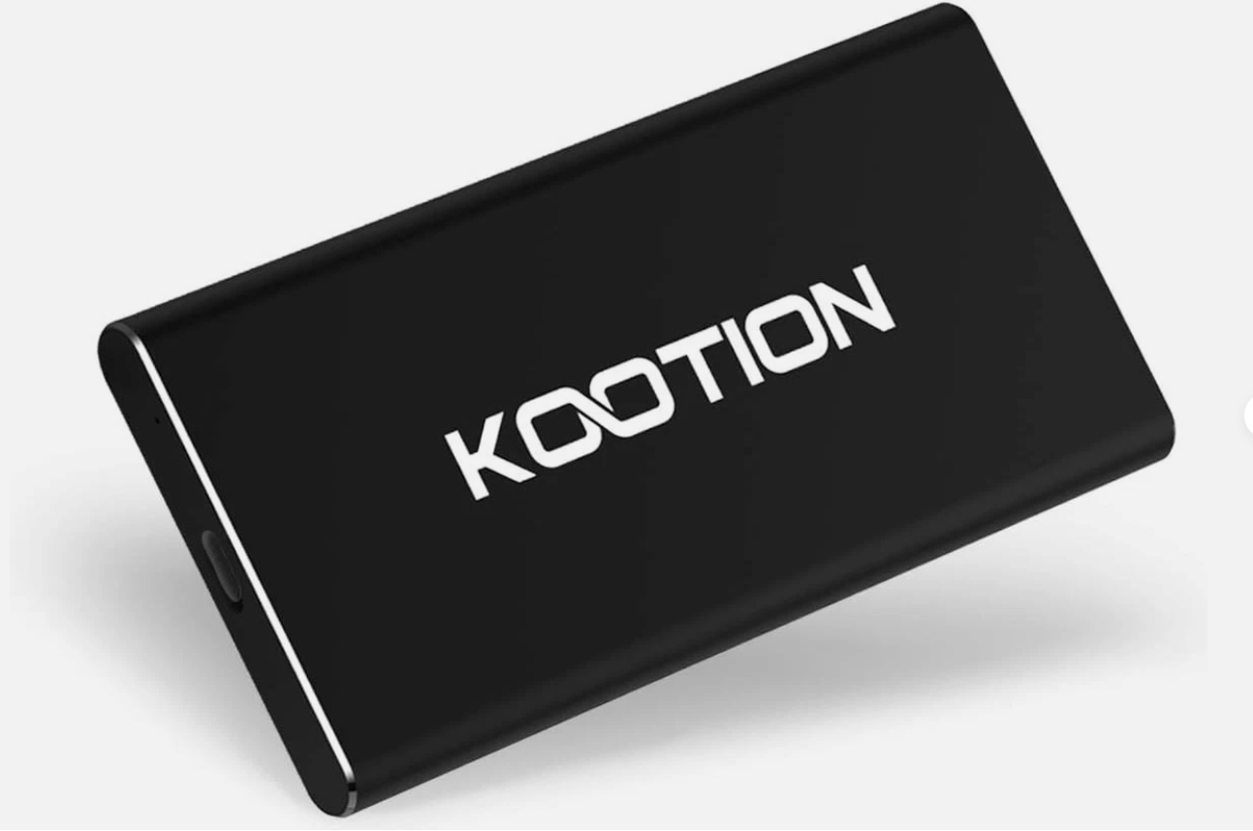
Product Overview

Brand | Unknown (Pending Title Confirmation)
Market Segment | Budget / Marketplace
Trust Rating | ★★
Estimated Price | Estimated $15–$35
Advertised Speed | Unknown — needs listing verification

Key Features
- Likely USB 3.0/3.1
- Basic portable form factor
- Unknown warranty or support
- eBay seller rating dependent
- May be refurbished or gray market

Strengths
- Low price attracts bargain hunters
- eBay marketplace has dedicated budget-buyer traffic
- Less strict compliance requirements vs. Amazon

Weaknesses
- No brand identity
- Trust entirely dependent on seller feedback score
- Inconsistent quality control across eBay sellers
- Difficult to scale revenue vs. Amazon FBA

Market Opportunity Assessment
Low-Medium for Amazon FBA strategy. eBay listings are useful to monitor for price floors and to identify OEM manufacturers. If the product appears on Alibaba/1688 as well, it confirms private-label potential.
Product 8 of 10

WD G-Technology External SSD
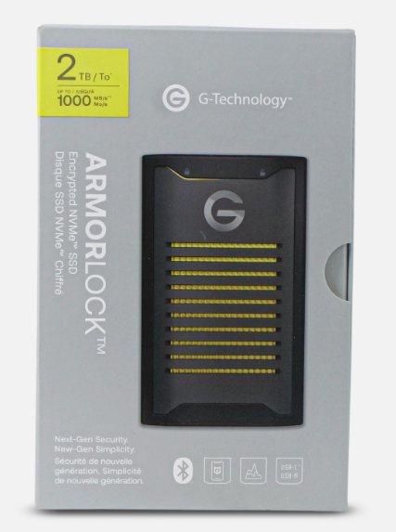
Product Overview

Brand | Unknown (Pending Title Confirmation)
Market Segment | Budget / Marketplace
Trust Rating | ★★
Estimated Price | Estimated $15–$35
Advertised Speed | Unknown — needs listing verification

Key Features
- USB interface type unconfirmed
- Portable SSD category assumed
- Seller terms and warranty unknown
- Possibly different form factor from Listing #1

Strengths
- Price competitiveness in eBay ecosystem
- Possible bulk/wholesale purchase opportunity
- Can be used to identify price elasticity in the market

Weaknesses
- No data on review volume, return rate, or sales velocity
- Zero brand equity
- eBay is not the primary battleground for FBA strategy

Market Opportunity Assessment
Similar to Listing #1 — primarily useful as a price intelligence source and potential OEM sourcing lead. Cross-reference with Alibaba to confirm factory origin.

Product 9 of 10
Product Page

Lexar 2TB ES3 External SSD
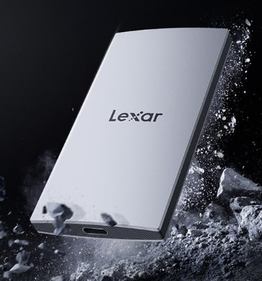
Product Page

Product Overview

Brand | Unknown (Pending Title Confirmation)
Market Segment | Budget (Estimated)
Trust Rating | ? (Unverified)
Estimated Price | Unknown — needs listing verification
Advertised Speed | Unknown — needs listing verification

Key Features
- ASIN confirmed; all other features require manual listing check
- Likely portable SSD based on research context
- Category, BSR, and review count to be retrieved

Strengths
- Active Amazon listing = indexed and potentially ranking
- If BSR is strong, indicates organic demand
- ASIN data can be pulled via tools like Helium 10 or Jungle Scout

Weaknesses
- No title = no competitive analysis possible yet
- Unknown seller type (FBA, FBM, Amazon itself)
- Unknown review health (star rating, recent velocity)

Market Opportunity Assessment
Unknown until listing is confirmed. Priority action: retrieve full listing title, BSR, review count, and price history. If it's a budget brand with under 500 reviews and a rising BSR, this could be a direct competitor to monitor.

Product 10 of 10

Yottamaster 1TB External SSD
Product Page

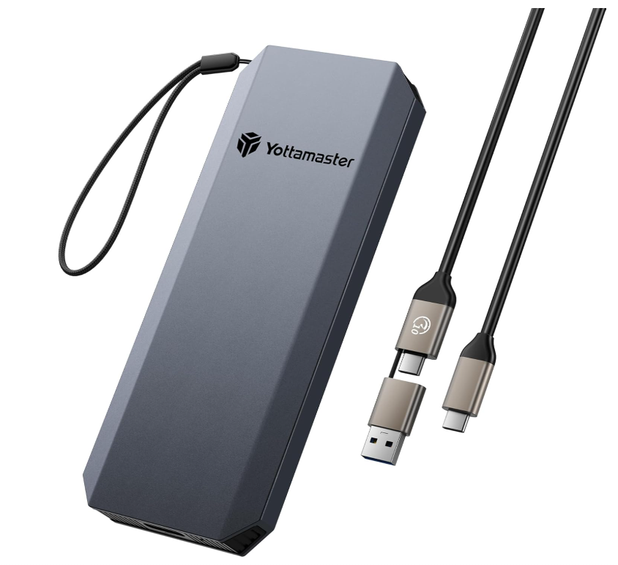
Product Overview

Brand | Unknown (Pending Title Confirmation)
Market Segment | Budget (Estimated)
Trust Rating | ? (Unverified)
Estimated Price | Unknown — needs listing verification
Advertised Speed | Unknown — needs listing verification

Key Features
- ASIN confirmed; all other features require manual listing check
- Portable SSD category assumed based on research context
- Review velocity and listing quality to be assessed

Strengths
- Live Amazon listing = real market presence
- Can be tracked via BSR history tools (Keepa, CamelCamelCamel)
- May reveal a sourcing partner or OEM supplier

Weaknesses
- Cannot assess competitiveness without title/specs
- BSR, price history, and review data all unknown
- Listing quality and A+ content status unknown

Market Opportunity Assessment
Unknown until confirmed. Use Keepa to pull BSR history — if the rank has been improving over 90 days, this product is gaining traction and warrants deeper analysis. If launched recently (< 6 months), it may confirm new entrants are succeeding.

Comparative Summary Table

The table below summarizes all 10 products for quick reference and side-by-side comparison.

# | Product | Brand | Segment | Trust | Competition | Opportunity
1 | SanDisk Extreme 1TB | SanDisk | Premium | ★★★★★ | Very High | Low
2 | Samsung T7 1TB | Samsung | Premium | ★★★★★ | Very High | Low
3 | Samsung T9 1TB | Samsung | Premium Pro | ★★★★★ | Very High | Low
4 | SSK Portable SSD | SSK | Budget | ★★★ | High | Medium
5 | Ediloca SSD | Ediloca | Budget | ★★★ | High | Medium
6 | OSCOO SSD | OSCOO | Budget | ★★ | High | Med-High
7 | eBay Listing #1 | Unknown | Budget | ★★ | Medium | Low-Med
8 | eBay Listing #2 | Unknown | Budget | ★★ | Medium | Low-Med
9 | ASIN B0DG6WRD8L | Unknown | Budget? | ? | Unknown | Unknown
10 | ASIN B0DTJXX2RV | Unknown | Budget? | ? | Unknown | Unknown

